Dear Parents,
Because we continually make theories about dependencies between quantities in nature and society, functions are important tools in the construction of mathematical models. A function can be described in various ways, such as by a graph (e.g., the trace of a seismograph); by a verbal rule, as in, “I’ll give you a state, you give me the capital city;” by an algebraic expression like f(x) = a + bx; or by a recursive rule. The graph of a function is often a useful way of visualizing the relationship of the function models, and manipulating a mathematical expression for a function can throw light on the function’s properties.

In this unit, students will:
- Analyze & interpret exponential functions in real-world applications.
- Build on and informally extend understanding of integer exponents to consider exponential functions.
- Use function notation.
- Interpret expressions for functions in terms of the situation they model.
- Analyze exponential functions and model how different representations may be used based on the situation presented.
- Build a function to model a relationship between two quantities.
- Recognize geometric sequences as exponential functions.
- Create new functions from existing functions.
- Construct and compare exponential models and solve problems.
- Reinforce their previous understanding of characteristics of graphs and investigate key features of exponential graphs.
- Investigate a multiplicative change in exponential functions.
- Create and solve exponential equations.
- Apply related linear equations solution techniques and the laws of exponents to the creation and solution of simple exponential equations.

Vocabulary
Web Sites for Support
GA Virtual Learning
- Understanding Exponential Functions
http://cms.gavirtualschool.org/Shared/Math/GSECoordinateAlgebra/UnderstandingLinearAndExponentialRelationships/index.html
- Analyzing Exponential Functions
http://cms.gavirtualschool.org/Shared/Math/GSECoordinateAlgebra/CreatingModelsofLinearAndExponentialRelationships/index.html
Web Sites
http://www.purplemath.com/modules/expofcns.htm exponential functions
http://www.regentsprep.org/regents/math/algtrig/ATP8b/exponentialFunction.htm exponential functions
http://www.mathsisfun.com/sets/function-exponential.html exponential functions
http://www.regentsprep.org/Regents/math/algtrig/ATP2/GeoSeq.htm geometric sequences
http://www.purplemath.com/modules/series3.htm geometric sequences
http://www.basic-mathematics.com/geometric-sequence.html geometric sequences
- Explicit Expression. A formula that allows direct computation of any term for a sequence a₁, a₂, a₃, . . . , a_{n}, . . . .
- Exponential Function. A nonlinear function in which the independent value is an exponent in the function, as in y = ab^{x}.
- Exponential Model. An exponential function representing real-world phenomena. The model also represents patterns found in graphs and/or data.
- Geometric Sequence. A sequence of numbers in which the ratio between any two consecutive terms is the same. In other words, you multiply by the same number each time to get the next term in the sequence. This fixed number is called the common ratio for the sequence.
- Recursive Formula. A formula that requires the computation of all previous terms to find the value of a_{n}. 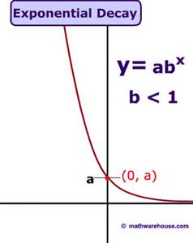
Textbook Connection
HMH Coordinate Algebra
Unit 3 Modules 12-13

Digital Access:
http://my.hrw.com
Ask your teacher for information
Exponential Growth & Decay  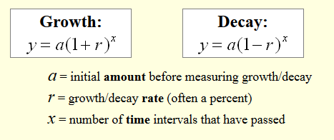 | Compound Interest  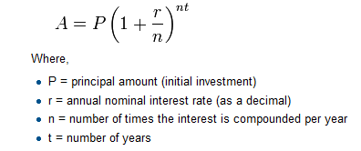
Geometric Sequence: Recursive  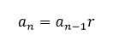 | Geometric Sequence: Explicit  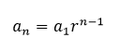

Sample Problems
- Tell whether each set of ordered pairs satisfies an exponential function. Explain your answer.
{(-1, 1), (0, 0), (1, 1), (2, 4)}
Yes; as the x-values change by a constant amount, the y-values are multiplied by a constant amount.

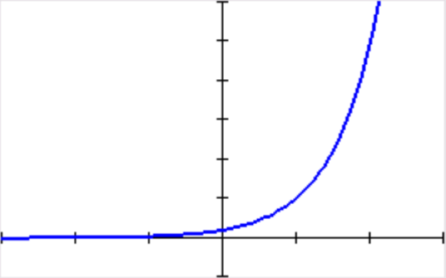
- Choose several values of $x$ and generate ordered pairs. Then use the ordered pairs to graph the function:
$y=0.2(5^{x})$
$$x$$ | $$y$$
-1 | .04
0 | .2
1 | 1
2 | 5

- In the definition of an exponential function, the value of $b$ cannot be 1, and the value of $a$ cannot be 0. Why?
If the value of $b$ were 1, the function would be constant.
If the value of $a$ were 0, the function would be the constant function of $y=0$.

- Technology Application:
Moore’s law states that the maximum number of transistors that can fit on a silicon chip doubles every two years. The function $f\left(x\right)=42{\left(1.41\right)}^{x}$ models the number of transistors, in millions, that can fit on a chip, where $x$ is the number of years since 2000. Using this model, in what year can a chip hold 1 billion transistors?
About 2009

- The population of a town is decreasing at a rate of 3% per year. In 2000, there were 1700 people. Write an exponential decay function to model this situation. Then find the population in 2012.
$$y=1700{\left(0.97\right)}^{t}$$
Population: 1180 people

