Dear Parents,

In this unit, students deepen their understanding of linear, quadratic, and exponential functions as they compare and contrast the three types of functions. Students distinguish between additive and multiplicative change and interpret arithmetic sequences as linear functions and geometric sequences as exponential functions. Students compare characteristics of linear, quadratic, and exponential functions. Students observe using graphs and tables that a quantity increasing exponentially eventually exceeds a quantity increasing linearly, quadratically, or (more generally) as a polynomial function. Students select from among these functions to model phenomena.

Standards
- Construct & Compare Linear, Quadratic, & Exponential Models & Solve Problems (F.LE.1-3)
- Interpret Expression for Functions in Terms of the Situations They Model (F.LE.5)
- Understand the Concept of a Function & Use Function Notation (F.IF.1-2)
- Interpret Functions that Arise in Applications in terms of the Context (F.IF.4-6)
- Analyze Functions using Different Representations (F.IF.7-9
- Build New Functions from Existing Functions (F.BF.3)

Web Resources  - Rate of Change: http://www.nms.org/Portals/0/Docs/FreeLessons/Fill%20It%20Up,%20Please%20-%20Part%20III.pdf  - Linear & Exponential Growth:  http://learnzillion.com/lessonsets/40-proving-how-linear-functions-grow  - Distinguishing between Linear & Exponential: http://learnzillion.com/lessonsets/35-distinguishing-between-linear-functions-and-exponential-functions  - http://www.virtualnerd.com/algebra-1/quadratic-equations-functions/linear-exponential-comparison | Textbook Connection  HMH Advanced Algebra Textbook  Unit 3, Module 13  Digital Access:  http://my.hrw.com  (Teacher has login information)

Formulas
General Forms of Functions
Linear  $$y=mx+b$$  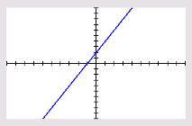 | Quadratic  $$y=ax^{2}+bx+c$$  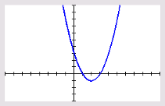 | Exponential  $$y=ab^x$$  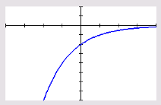
Sample Problems
- Graph the set of data. Which kind of model best describes the data?
{(-1, 4), (-2, 0.8), (0, 20), (1, 100), (-3, 0.16)}
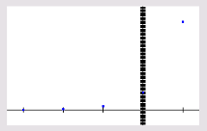
Exponential

- Describe the rate of change for linear, quadratic, & exponential functions.
Linear: Constant
Quadratic: Variable
Exponential: Variable
(Average rate of change will eventually be greater than quadratic or linear rates of change.)

- Determine which function model the data in the table represents:
Height of Bridge Suspension Cables
Cable’s Distance from Tower (ft) | Cable’s Height (ft)
0 | 400
100 | 256
200 | 144
300 | 64

Quadratic Function

- A town home has approximately 500 homes. The town council is considering plans for future development. Plan A calls for an increase of 50 homes per year. Plan B calls for a 5% increase each year. Compare the plans.

Plan A: $y=50x+500$
Plan B: $y=500{\left(1.05\right)}^{x}$
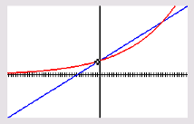
More homes will be built under plan A up to the end of the 26th year. After that, more homes will be built under plan B, and plan B results in more homes than plan A by ever-increasing amounts each year.

